PRACTICAL- 1

Implement a function for each of following problems and count the number of steps executed/Time taken by each function on various inputs and write complexity of each function. Also draw a comparative chart. In each of the following function N will be passed by user.

1. To calculate sum of 1 to N number using loop.
2. To calculate sum of 1 to N number using equation. 3. To calculate sum of 1 to N numbers using recursion.

CODE:

#include <stdio.h>

int count_loop=0; int count_rec=0;

int count_eq=0;

void loop(int ); int rec(int ); void eq(int );

int main()

{ int n;

printf("enter value of n =");

scanf("%d",&n);

loop(n); eq(n);

int recursion=rec(n);

printf("sum of rec=%d\n",recursion);

printf("rec count=%d",count_rec);

return 0;

}

void loop(int n){ int

sum_loop=0; for(int i=0;i<=n;i++){ sum_loop=sum_loop+i;

count_loop++;

}

printf("LOOP__________________\n"); printf("sum of loop=%d\n",sum_loop); printf("loop

count=%d\n",count_loop);

}

void eq(int n){ int sum_eq=0; count_eq; sum_eq=(n*(n+1))/2; count_eq++; printf("\nEQUATION__________________\n"); printf("sum of eq=%d\n",sum_eq); printf("eq count=%d\n",count_eq); printf("\nRECUSRION__________________\n");

}

int rec(int n){ if (n <=

1){

count_rec++; return n;

} else {

count_rec++; return

n + rec(n - 1);

}

}

OUTPUT:

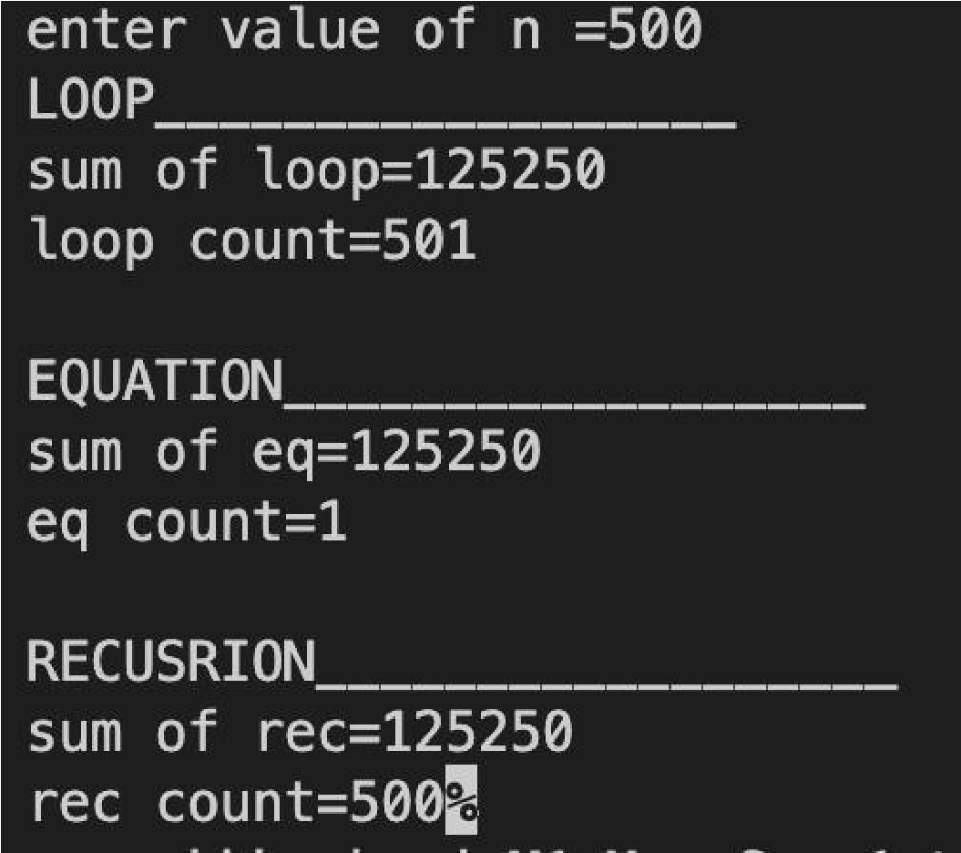

Graph :

